ALCOHOL PRACTICE SHEET key

1. Draw the major organic products formed in the following reactions, clearly showing all appropriate regio- and stereochemistry.























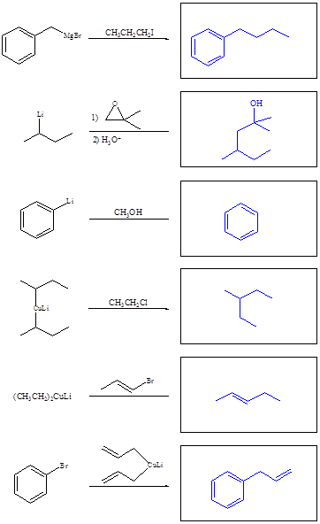

1. Provide starting materials in the boxes below to complete the following reactions.



(a)



(b)



(c)

1. Each of the following conversions requires more than one step. Show reagents and experimental conditions necessary to bring about each conversion.



(a)



(b)



c)

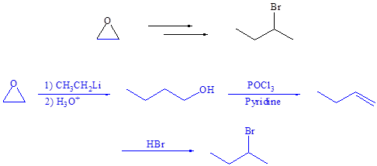

d)

